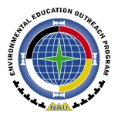
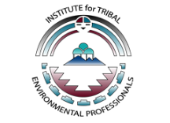
Northern Arizona University (NAU)
Institute for Tribal Environmental Professionals (ITEP)
Environmental Education Outreach Program (EEOP)
Research Education on Air and Cardiovascular Health (REACH)
ITEP-EEOP is focused on creating STEM opportunities for Native American students, their families and communities. Once we receive this application, we will set up a call to discuss the REACH program.

School:
Educator Contact Name:
Tribal Staff Contact Name:
Contact Phone Number:
Contact email:
Grade(s):
Describe classes or students you plan to involve in REACH:

What are some ideas for incorporating REACH into your educational program?

Please fill out and return to Mansel Nelson at mansel.nelson@nau.edu.

